The Phillips Curve Is Not What You Think It Is
François Geerolf
2021-04-12
Translated from French: « La courbe de Phillips n’est pas celle que vous croyez » F. Geerolf, La Lettre du CEPII, n°417, avril 2021, hal-05235044.
In the wake of the Covid-19 crisis, stimulus policies have once again moved to the forefront of the economic policy debate. In the United States, some economists fear that Joe Biden’s $1.9 trillion stimulus plan could push unemployment too low and trigger an inflationary spiral (an overheating phenomenon). In Europe, many consider the stimulus plans insufficient, meaning that unemployment could remain persistently too high, posing a deflationary risk. These analyses share a common assumption: the existence of a Phillips curve, that is, a downward-sloping relationship between unemployment and inflation. Yet this cornerstone of macroeconomic thinking has long been under fire. Indeed, economic history is marked by episodes in which such a relationship is difficult to observe. Is the Phillips curve therefore doomed to join the list of economic laws that no longer work—or no longer work at all? In this form, certainly. But not in a version more consistent with empirical observation, which shows that behind the Phillips curve there is in fact a negative relationship between unemployment and real exchange rate appreciation—equal to inflation under fixed exchange rates, hence the confusion (Geerolf, 2018). This reinterpretation of the Phillips curve has important implications for economic policy. First, it suggests that the relevant trade-off is not between inflation and unemployment, but between competitiveness and unemployment. It also implies that the level of inflation is a poor guide for macroeconomic policy: inflation is not a sign of excessive demand, any more than the absence of deflation is a sign of sufficient demand. Finally, there is no natural rate of unemployment below which an inflationary spiral would be triggered, as in the 1970s and 1980s. This should put into perspective the concerns currently raised about stimulus policies.

The Phillips Curve: A Not-So-Stable Pillar of Macroeconomics
In the late 1950s, the economist A.W. Phillips identified a downward-sloping relationship between the unemployment rate and the growth of nominal wages in Great Britain between 1861 and 1913. A simple explanation was quickly proposed: when unemployment is low, firms struggle to recruit, which leads them to offer higher (nominal) wages. Conversely, in periods of high unemployment, bargaining power does not favor workers, leading to wage moderation. Assuming a direct link between nominal wage growth and inflation, this implies a negative relationship between unemployment and inflation.
The Phillips curve quickly became a cornerstone of macroeconomics. As early as 1960, Paul Samuelson and Robert Solow, after identifying a similar relationship in the United States, amplified Phillips’s contribution by placing the curve at the heart of the “neoclassical synthesis,” the bridge between Keynesian and neoclassical theory. In this framework, the economy is Keynesian in the short run and neoclassical in the long run. The Phillips curve illustrates the trade-off between unemployment and inflation and the short-run policy dilemma faced by governments: choosing a combination of unemployment and inflation rates under the constraint that low unemployment comes at the cost of higher inflation.
Subject to repeated controversies, each challenge to the Phillips curve has led to a reformulation that ensures its survival. The most famous of these was proposed by Edmund Phelps and Milton Friedman in the late 1960s. For them, the true relationship—known as the expectations-augmented Phillips curve—links changes in inflation to the gap between the unemployment rate and the natural rate of unemployment. The latter is the unemployment rate that does not accelerate inflation, known as the Non-Accelerating Inflation Rate of Unemployment (NAIRU). This new formulation is far less favorable to Keynesian policies, since demand-side stimulus policies aimed at pushing unemployment below its natural level would result in ever-accelerating inflation. Moreover, the NAIRU is generally estimated to be high: for instance, the 2000 report Full Employment by the French Council of Economic Analysis placed it between 8% and 10% in France. From a policy perspective, this augmented version of the Phillips curve has, since the 1990s, provided justification for inflation-targeting monetary policies as well as for structural labor market reforms aimed at increasing flexibility—seen as the only way to reduce the natural rate of unemployment.
Yet this expectations-augmented Phillips curve quickly proved disappointing, starting in the 1980s. Observing its many empirical shortcomings—particularly in explaining unemployment in Europe—Larry Summers asked in 1991: “Should Keynesian economics dispense with the Phillips curve?”.
In the late 1990s, during the dot-com bubble, unemployment in the United States fell well below the NAIRU without generating any inflationary pressure. In the 2000s, both the European Central Bank and the Federal Reserve raised interest rates several times as unemployment appeared to approach its natural level, even though no inflationary tensions were visible. The 2007–2009 crisis, despite its severity and the sharp rise in unemployment it caused, did not lead to the feared deflation. Nor was the fiscal expansion under Donald Trump (2017–2020) followed by a resurgence of inflation. If, time and again, the Phillips curve—despite its successive modifications—disappears from the empirical landscape, does this mean we should abandon the idea of any stable relationship between unemployment and prices?

A Solid Pillar: The Exchange-Rate Phillips Curve
In its traditional forms, it is difficult to argue that a stable relationship exists. However, if we relate unemployment not to inflation but to changes in the real exchange rate (i.e., relative inflation expressed in a common currency), a stable negative relationship emerges between unemployment and real exchange rate appreciation (Geerolf, 2018).
Under fixed exchange rate regimes, this reinterpretation does not contradict Phillips’s original insight, since inflation and real exchange rate appreciation coincide in such regimes. This explains the existence of a Phillips curve in countries with fixed exchange rates, such as Great Britain between 1861 and 1913 (under the gold standard), or the United States, which stood at the center of the Bretton Woods system until 1971 (Figure 1). Similarly, Phillips curves are regularly identified across U.S. states, regions within a country, countries within the euro area, or countries sharing a common currency.
Figure 1: The Phillips curve was clearly visible in the United States during the Bretton Woods period; it disappears thereafter. Source: author’s calculations based on the FRED database.
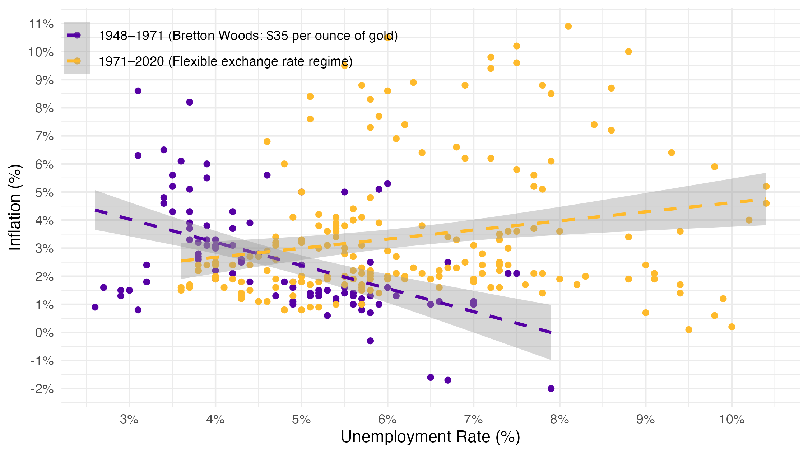
This is what Figure 2 illustrates more broadly: for OECD countries under fixed exchange rate regimes, a clear negative relationship between unemployment and inflation can indeed be observed over the period 1960–2016.
By contrast, under flexible exchange rate regimes, the correlation between inflation and unemployment is positive, which invalidates the traditional Phillips curve. To recover a negative relationship between unemployment and prices—regardless of the exchange rate regime—it is necessary to consider not overall inflation, but relative inflation: that of non-tradable goods relative to tradable goods, i.e., changes in the real exchange rate.
Figure 2: The traditional Phillips curve is only observed under fixed exchange rate regimes, whereas the real exchange rate Phillips curve holds regardless of the exchange rate regime. Sources: author’s calculations based on Geerolf (2018), OECD data, and Ilzetzki et al. (2019) for the classification of exchange rate regimes.
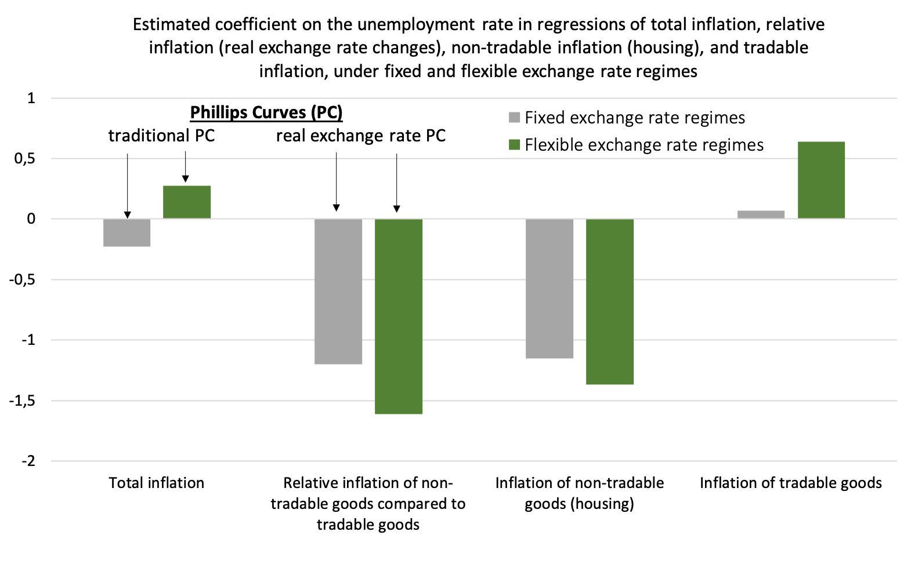
Decomposing the effect of the unemployment rate on inflation into its two components (non-tradable goods and tradable goods) helps explain why this is the case.
Under both fixed and flexible exchange rate regimes, a decline in unemployment driven by higher demand is associated with upward pressure on the demand for non-tradable goods, whose supply is limited. As a result, their prices increase—this is particularly true for housing prices and rents. The relationship between unemployment and inflation in non-tradable goods is therefore negative.
For tradable goods, the relationship between unemployment and inflation depends on the exchange rate regime. Under fixed exchange rates, the relationship is null: since prices are set on global markets and the exchange rate does not vary, there is no reason to observe a systematic link with unemployment. Under flexible exchange rates, however, the relationship is positive: when unemployment falls, the nominal exchange rate tends to appreciate, which pushes down the price of tradable goods in domestic currency. This nominal appreciation stems from central bank actions aimed at limiting inflation. As seen earlier, a decline in unemployment leads to inflation in non-tradable goods, which central banks counter by raising policy rates—thus triggering, under flexible exchange rates, an appreciation of the currency. The relationship between unemployment and inflation in tradable goods is therefore either null or positive.
Since the traditional Phillips curve relates unemployment to overall inflation—i.e., a weighted average of inflation in tradable and non-tradable goods—it is more likely to be observed under fixed exchange rates, where the relationship is negative for non-tradable goods and null for tradable goods. By contrast, under flexible exchange rates, if the (positive) effect of unemployment on tradable goods inflation—weighted by their share in consumption—exceeds the (negative) effect on non-tradable goods inflation (also weighted), the Phillips curve is reversed.
By contrast, the exchange-rate Phillips curve holds regardless of the exchange rate regime, as it relates unemployment to the relative inflation of non-tradable goods compared to tradable goods—a relationship that is always negative.

The Exchange-Rate Phillips Curve Offers a Different View of Economic Policy
The exchange-rate Phillips curve has important implications for the conduct of economic policy. First, it shows that the relevant trade-off is not between lower unemployment and lower inflation, but between lower unemployment and higher competitiveness. This implies that the risks associated with Keynesian stimulus are not about inflation, but about a deterioration in the competitiveness of the export sector, leading to a reallocation of production away from manufacturing toward construction and non-tradable services, and thus to accelerated deindustrialization. This trade-off between stimulus and loss of competitiveness has been faced by many policymakers. The deterioration of U.S. competitiveness following the Keynesian policies of the 1960s was one of the reasons that led Richard Nixon to devalue the dollar in 1971. Similar dynamics have been observed in emerging economies (Argentina 1991–2000, Southeast Asia in the 1990s) and in Southern Europe (Greece, Spain, Ireland in the early 2000s). This problem, however, only arises in the case of uncoordinated stimulus policies, and thus argues for coordinated stimulus across countries, such as that implemented at the G20 meeting in Washington in 2008. The trade-off between demand stimulus and external balance was already central to the thinking of J.M. Keynes, who advocated the use of tariffs to mitigate these effects when coordinated stimulus was not possible.
The absence of a traditional Phillips curve also implies that the level of inflation is not a good guide for macroeconomic policy, and that stabilizing inflation is neither necessary nor sufficient to stabilize economic activity. For instance, the stagflation of the 1970s was interpreted as a sign of excessive demand—since, under the traditional Phillips curve, insufficient demand should have led to deflation—which led to austerity policies (notably the sharp increase in U.S. interest rates in the 1980s). However, using the exchange-rate Phillips curve, one can understand that the coexistence of unemployment and inflation during that period stemmed from the real depreciation of the dollar caused by its nominal devaluation at the end of Bretton Woods—an explanation consistent with deficient demand.
Similarly, the “missing deflation” in 2007–2009 does not imply that the financial crisis was accompanied by a supply shock, contrary to what a New Keynesian approach relying on the traditional Phillips curve would suggest. Finally, in 2011, the European Central Bank’s rate hikes could have been avoided: the increase in inflation was not a sign of overheating in the European economy—which was in fact undergoing fiscal austerity between 2010 and 2013—but rather the consequence of euro depreciation and thus imported inflation, as described by the exchange-rate Phillips curve. The absence of deflation following this policy mistake is not inconsistent with the fact that economic activity has since remained durably below potential in Europe, particularly compared with the United States.
Finally, the absence of a Phillips curve linking inflation and unemployment calls into question the usual criticisms of demand-support policies. The debates surrounding the limits of Keynesian policy—still very much alive today in discussions about stimulus plans—echo those raised by postwar Keynesian economists such as Alvin Hansen, who emphasized the hypothesis of “secular stagnation,” driven by an excess of long-term savings. In such a context, a permanent stimulus to demand—made possible by sustained public deficits—is the only way to durably return to full employment. As long as private saving remains at current levels, public deficits are likely to persist—and there is little reason for concern.

Geerolf, F. (2018). The Phillips Curve: A Relation between Real Exchange Rate Growth and Unemployment (pp. 1–55) [UCLA Working Paper].
This theoretical interpretation, based on microeconomic reasoning, is far from fully convincing: in principle, tightness in the labor market should lead to an increase in wages relative to inflation—that is, an increase in real wages—rather than higher inflation.
It is difficult to provide an exhaustive survey of these reformulations: several thousand research articles have been devoted to the Phillips curve. For more on this history: Le Bihan, H. (2009). 1958–2008, avatars et enjeux de la courbe de Phillips. Revue de l’OFCE, n° 111(4), 81–101.
New Keynesians differ from Milton Friedman mainly in that they believe only active stabilization policies can bring the economy back to its natural rate of unemployment, rather than the economy returning to it on its own.
Pisani-Ferry, J., Blanchard, O. J., Charpin, J. M., & Malinvaud, E. (2000). Full Employment, Report of the Council of Economic Analysis no. 23, La Documentation française.
Summers, L. H. (1991). Should Keynesian Economics Dispense with the Phillips Curve? In Issues in Contemporary Economics (pp. 3–20). Palgrave Macmillan, London.
See, for example, Fitzgerald, T. J., & Nicolini, J. P. (2014). Is There a Stable Relationship between Unemployment and Future Inflation? Evidence from U.S. Cities, Federal Reserve Bank of Minneapolis, Working Paper n°713.
On the link between accelerated deindustrialization and aggregate demand, see also Geerolf, F., & Grjebine, T. (2020). Deindustrialization (accelerated): The role of macroeconomic policies. Economie Mondiale 2021, 41–54, as well as Geerolf, F., & Grjebine, T. (2020). Rebalancing the euro area: Easier with the right diagnosis! La Lettre du CEPII, no. 411.
According to H.R. Haldeman’s diary (National Archives), Richard Nixon said during a cabinet meeting on August 16, 1971: “We are not competitive in producing cars, steel, or airplanes. Are we doomed to produce only toilet paper and toothpaste?”
Keynes, J. M. (March 7, 1931), Proposals for the Establishment of a New Tariff, The New Statesman and Nation. He later developed this argument more extensively in Chapter 23 of The General Theory of Employment, Interest and Money, and even partially rehabilitated mercantilist ideas.
See, for example, Beraja, M., Hurst, E., & Ospina, J. (2019). The Aggregate Implications of Regional Business Cycles. Econometrica, 87(6), 1789–1833.
On excess saving, see for theory Geerolf, F. (2019). A Theory of Demand Side Secular Stagnation [UCLA Working Paper] and Geerolf, F. (2013). Reassessing Dynamic Efficiency [UCLA Working Paper] for empirical evidence.

